Project Description

ModLog – Portable MODBUS data recorder  
EE537 – University of Alabama at Birmingham

**Group 9**

James M. Olson, OLSONJM

**Purpose**

Provide a stand-alone device which directly connects to external client devices via MODBUS protocol for the purpose of downloading real time system data onto an SD card for the purpose of trending. SD card can be removed from the device and the data can be used for external analysis.

**Project Requirements**

1. Connect to client MODBUS devices via RJ45 Ethernet and/or 2-wire RS485.
2. Ability to download and store client data via MODBUS protocol.
3. Store trend data to local SD card as plain ASCII text file.
4. Integral web server that provides status of connection and the latest measurement data.
5. Ability to change trend device settings.
   1. Change static IP address
   2. Client device model selection.
6. Integrate at least 3 different MODBUS client device models.
7. Integral real time clock (RTC) for time stamping of measurements.
8. Battery for momentary loss of power ride-through and controlled shutdown.
9. Local display showing IP Address, % storage used, battery status, and client connection status.
10. Single measurement to occur on fixed time interval.

**Future Development**

1. Both RS485 serial and RJ45 interface as standard (MODBUS serial RTU & TCP). With software selection of desired interface.
2. Second module which can be used to provide protocol translation to client devices which do not inherently communicate via MODBUS (i.e. CAN, SPI, I2C).
3. Bluetooth interface (disable/enable via software) and phone application for viewing data.
4. Automatic MIN, MAX, and AVERAGE calculation for each time interval measurement.
5. User adjustable time sampling rate.
6. Event triggers for forced time sampling (i.e. trigger on high current or low voltage).
7. Automatic network RTC clock synchronization

Hardware Platform

Selected Project Micro-controller & Peripherals

**Adafruit Feather M0 $21.95**

[https://www.adafruit.com/products/2796 (Links to an external site.)](https://www.adafruit.com/products/2796)

[adafruit-feather-m0-adalogger.pdfView in a new window](https://uab.instructure.com/files/56696264/download?download_frd=1)

* Measures 2.0" x 0.9" x 0.28" (51mm x 23mm x 8mm) without headers soldered in
* Light as a (large?) feather - 5.3 grams
* ATSAMD21G18 @ 48MHz with 3.3V logic/power
* 256KB of FLASH + 32KB of RAM
* No EEPROM
* 3.3V regulator with 500mA peak current output
* USB native support, comes with USB bootloader and serial port debugging
* You also get tons of pins - 20 GPIO pins
* Hardware Serial, hardware I2C, hardware SPI support
* 8 x PWM pins
* 10 x analog inputs
* Built in 100mA lipoly charger with charging status indicator LED
* Pin #13 red LED for general purpose blinking
* Power/enable pin
* 4 mounting holes
* Reset button

**DS3231 Precision RTC $13.95**

<https://www.adafruit.com/products/3028>

[ds3231-precision-rtc-featherwing.pdfView in a new window](https://uab.instructure.com/files/56696284/download?download_frd=1)

* DS3231 RTC
* Temperature compensated crystal oscillator
* I2C Interface

**Ethernet Interface Board $19.95**

[https://www.adafruit.com/products/3201](https://www.adafruit.com/products/3201 )

[adafruit-wiz5500-wiznet-ethernet-featherwing.pdfView in a new window](https://uab.instructure.com/files/56696310/download?download_frd=1)

* RJ45 Interface
* WIZ5500 Chipset
* SPI interface

**OLED Display 128x32 Board $14.95**

<https://www.adafruit.com/products/2900>

[adafruit-oled-featherwing.pdfView in a new window](https://uab.instructure.com/files/56696357/download?download_frd=1)

* 128x32 Monochrome
* I2C interface
* 3 integral push buttons + reset button

**100mAh Lithium Ion Polymer Battery $5.95**

[https://www.adafruit.com/products/1570](https://www.adafruit.com/products/1570 )

* 3.7V (4.2V full charge), 100 mAh
* JST connector

Project Material Costs

Projected BOM

|  |  |  |  |  |  |  |
| --- | --- | --- | --- | --- | --- | --- |
| ModLog - Project Material Cost List | | | |  |  |  |
|  |  |  |  |  |  |  |
| EE537 - Microcontroller Applications | | | | **Project Total** | **$86.75** |  |
|  |  |  |  |  |  |  |
|  |  |  |  |  |  |  |
| Quantity | Cost | Part# | Supplier | Description | Link | Line Total |
| 1 | $21.95 | 2796 | [www.adafruit.com](http://www.adafruit.com/) | Adafruit Feather M0 Adalogger | [www.adafruit.com/products/2796](http://www.adafruit.com/products/2796) | $21.95 |
| 1 | $19.95 | 3201 | [www.adafruit.com](http://www.adafruit.com/) | Adafruit Feather Ethernet Wing | [www.adafruit.com/products/3201](http://www.adafruit.com/products/3201) | $19.95 |
| 1 | $13.95 | 3028 | [www.adafruit.com](http://www.adafruit.com/) | Adafruit DS3231 Precision RTC | [www.adafruit.com/products/3028](http://www.adafruit.com/products/3028) | $13.95 |
| 1 | $14.95 | 2900 | [www.adafruit.com](http://www.adafruit.com/) | Adafruit 128x32 OLED Display | [www.adafruit.com/products/2900](http://www.adafruit.com/products/2900) | $14.95 |
| 1 | $5.95 | 1570 | [www.adafruit.com](http://www.adafruit.com/) | Lithium Ion 3.7V 100mAh Battery | [www.adafruit.com/products/1570](http://www.adafruit.com/products/1570) | $5.95 |
| 1 |  |  | TBD | Enclosure |  | $5.00 |
| 1 |  |  | TBD | Base PCB |  | $5.00 |

Microcontroller I/O Use

Projected utilization of hardware I/O

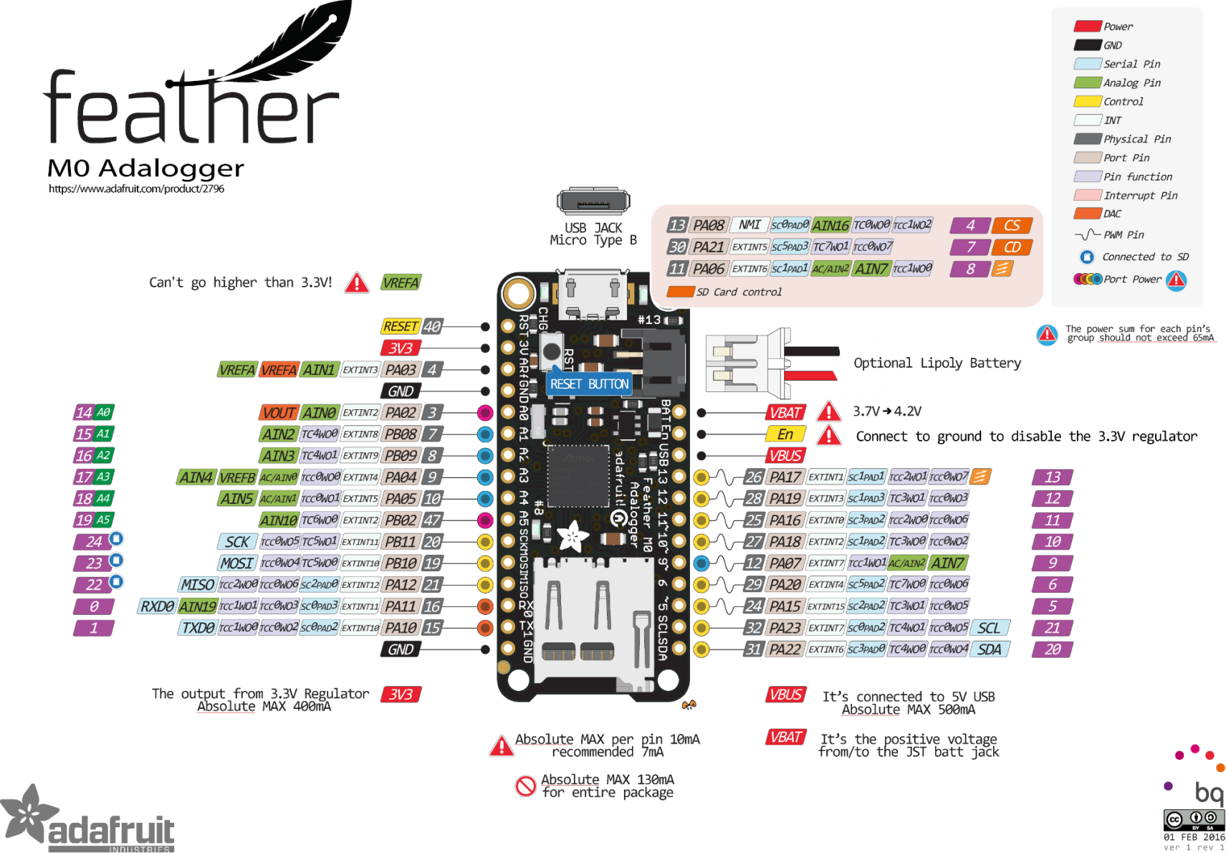

Main board Pins: Battery, Enable & USB (1), Analog Input 7 (Pin #9) dedicated for measuring battery voltage.

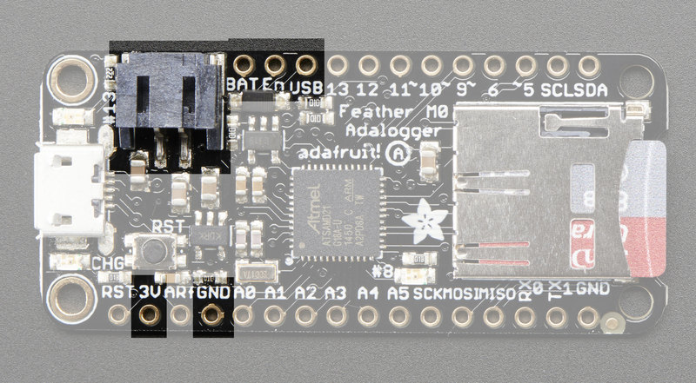

Battery Measure Pin

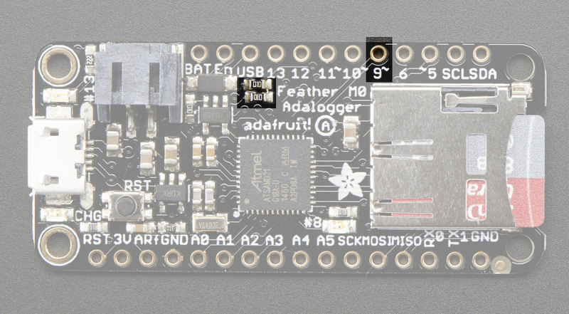

RTC uses power pins 3V & GND (1), and I2C Bus Lines SDA & SCL (Address = 0x68) (1). Reset pin also connected (2).

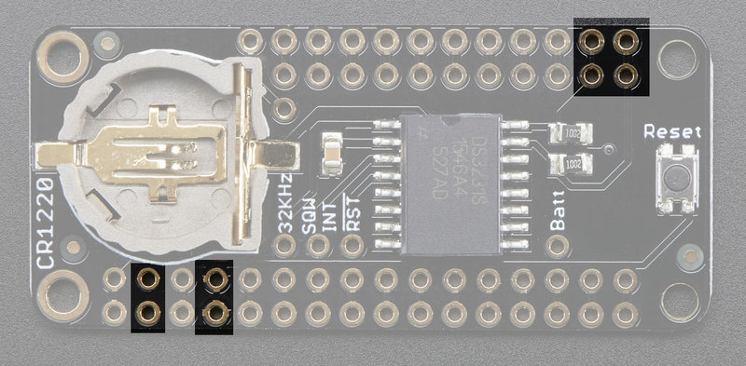 (1)

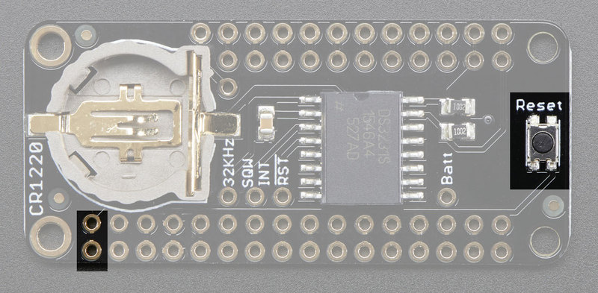 (2)

Ethernet Board uses 3.3V and GND pins(1), SPI Bus pins MOSI/MISO/SCK (2), and Chip select on Pin #10 (3).

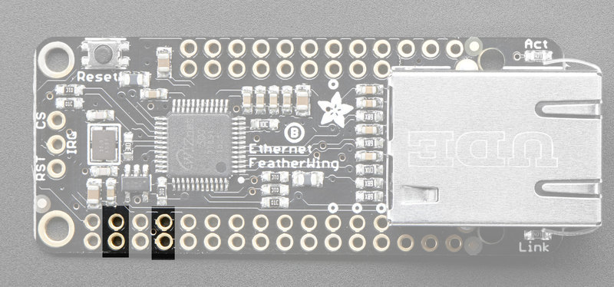 (1)

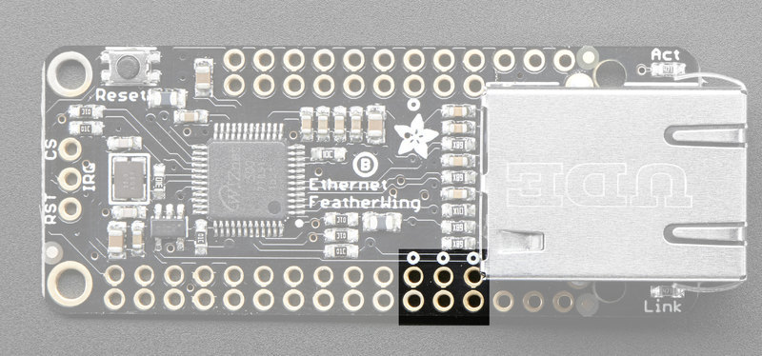 (2)

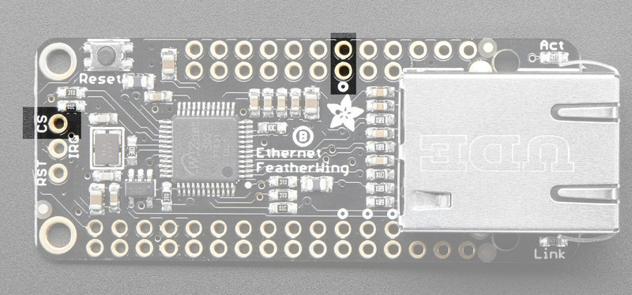 (3)

OLED Display uses 3.3V and ground pins (1), I2C Data pins SDA & SCL (Address = 0x38) (2), the three push buttons go to pins A = #9, B = #6, C = #5.

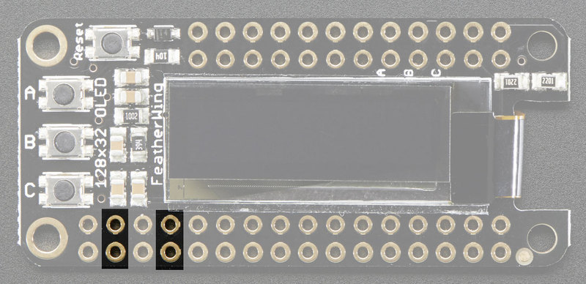 (1)

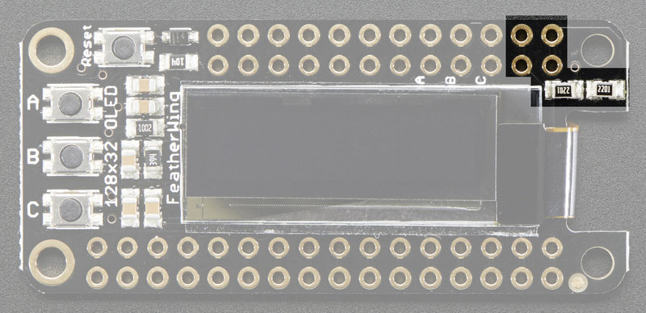 (2)

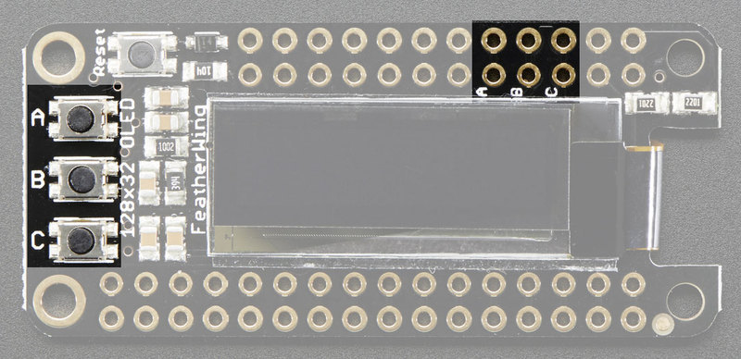 (3)

Project Milestones

Project Progress Points

1. Definition of project scope & hardware/software requirements

*STATUS: Completed*

1. Selection of hardware platform and peripherals.

STATUS: *Completed*

1. Purchase of hardware & functional integration testing of peripherals.  
    STATUS: *Completed.*

*Read/write to RTC successful. Verified clock is holding.*

*OLED display interface functional. Push data + button interface working.*

*Ethernet interface + web server functioning. Read/write data*

*Battery pack charge/discharge verified w/ 100mAh battery.*

1. Obtaining & testing MODBUS slave device for prototype testing.  
   STATUS: *Completed.*

*Installed Eaton IQ2270 power quality meter on house panel.*

1. Developing of base code to read data from MODBUS slave.  
    STATUS: *Completed*

*Verified ability to read Modbus data from slave device and*

*Push data up to Web Server interface & OLED display.*

1. Developing SD card data storage algorithms.  
    STATUS: *Completed*

*Verified read/write capability to SD card.*

*Push real time data at set time interval.*

1. Developing integral web server interface.

STATUS: *Completed*

*Basic web server interface is functional.*

*Displaying real-time data as plain text.*

1. Develop battery & device power up/down logic & hardware.

STATUS: *Completed*

*Battery charger circuit functional & USB/Batt V displayed on OLED*

1. Enclosure selection & thermal design/testing.

STATUS: *Completed*

*7-day burn-in successful without interruption or thermal issues*

1. Final Documentation & burn-in testing.

STATUS: *Completed*

*Project documentation submitted. Device fully functional*

External References

Hardware & Protocol Reference Material

Good Description of MODBUS request byte formatting by Simply Modbus

[http://www.simplymodbus.ca/TCP.htm](http://www.simplymodbus.ca/TCP.htm )

Basic Introduction to MODBUS TCP protocol by ProSoft

[intro_modbustcp.pdfView in a new window](https://uab.instructure.com/files/56696144/download?download_frd=1)

MODSCAN Software – Used for verifying data & packets over the network

<http://www.win-tech.com/html/modscan32.htm>

MgsModbus - Template for MODBUS TCP interface C++ Class (MODBUS MASTER)

[http://myarduinoprojects.com/modbus.html](http://myarduinoprojects.com/modbus.html )

[MgsModbus-v0.1.1.zipView in a new window](https://uab.instructure.com/files/56696172/download?download_frd=1)